**MINCOM REASSURES SUPPORT TO REP-COD DELEGATION**

The Minister of Communication has on July 9, 2020 in the company of some of his immediate collaborators, received in audience the President of the Parliamentary Network for the Diaspora, Decentralized and Cross-border Cooperation (REP-COD).

Hon. Louis Ngantcha and some bureau members of the network were in the ministry to tap experience, to solicit for collaboration with the Ministry of Communication in the effort to promote the image of Cameroon and to beef up relationship between Cameroonians at home and those in the diaspora.

He said the development of Cameroon lies in the hands of Cameroonians and that they seek to meet Cameroonians at home and abroad, educate and build a sense patriotism for the common good of all irrespective of their political and different shades of opinions.

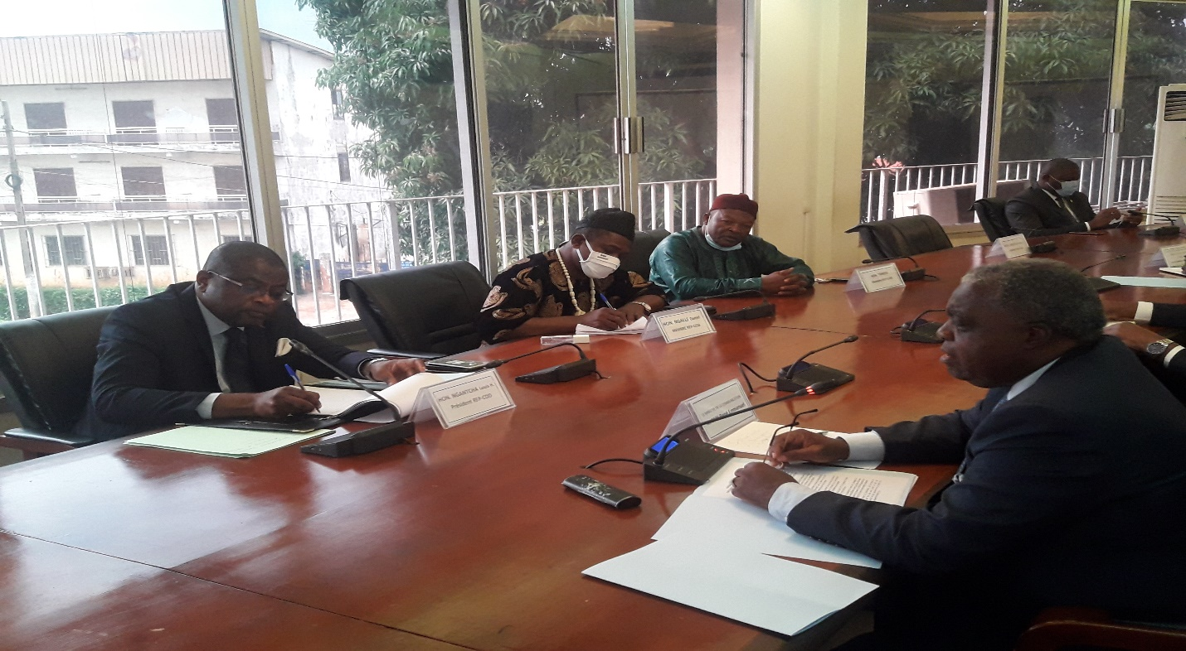

*REP-COD Delegation in audience with Minister Rene Sadi*

In response, Minister Rene Sadi saluted the initiative, acknowledging that Cameroonians have a duty to promote the image of Cameroon and that only when the image is good that investors will be attracted to invest in the country. He indicated the Ministry’s readiness to collaborate and provide them the necessary technical assistance whenever the need arises. He presented and counted on the services of his ministerial departments that has the competence with regards to their request, the different communication centers abroad and the CRTV.