**Promotion of Bilingualism and Multiculturalism: MINCOM Receives Delegation**

The three-man working group on multiculturalism headed by Professor Abbé Jean Marie BODO was received by the Secretary General, Professor Felix Zogo on behalf of the Minister of Communication on Tuesday, August 25. Besides other specific objectives according to Professor BODO, the global objective of their visit was to gather information in order to ascertain the effective practice of bilingualism in ministerial departments in force, and most especially following the promulgation of the law of 24 December 2019 on the promotion of bilingualism in Cameroon. Addressing the team, the Secretary General who was flanked by immediate collaborators presented a status quo on the functioning of the ministry and however laments over the absence of translation units at the level of the various regional delegations.

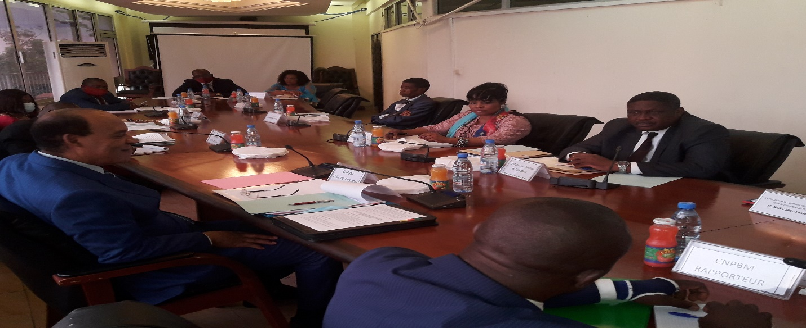

***The Group in a working session with MINCOM Delegation***

Other issues raised centered on how bilingualism could be effectively instituted and practiced in the ministry and in response, Professor BODO prescribed among others that all official documents such as communiques must be done in the two official languages, French and English, adding that characters and fonts of titles must be in same font and character size in the two official languages. He advised that ascending to certain post of responsibility should be based on the individual’s capacity of the mastery of both languages. He finally called for all the recommendations to be implemented with immediate effect. The visit ended with a working session between the team and some officials of the ministry.