**COVID-19: Mobile Caravans reinforce communication**

The use of mobile caravans to communicate and sensitize the population against covid-19 has been introduced in the six councils of the Mfoundi division of the Centre region as a precursor to a nationwide communication campaign in the days to come in the other regions of the country. Speaking during the official launch at the conference room annex in the ministry of communication, Minister Rene Sadi, flanked by Minister Mounouna Foutsou of Youth and Civic Education and Jacque Boyer, UNICEF Resident Representative, called for the continuous respect of the government measures as laid down by the Prime Minister.

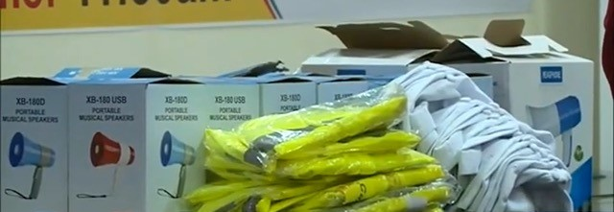

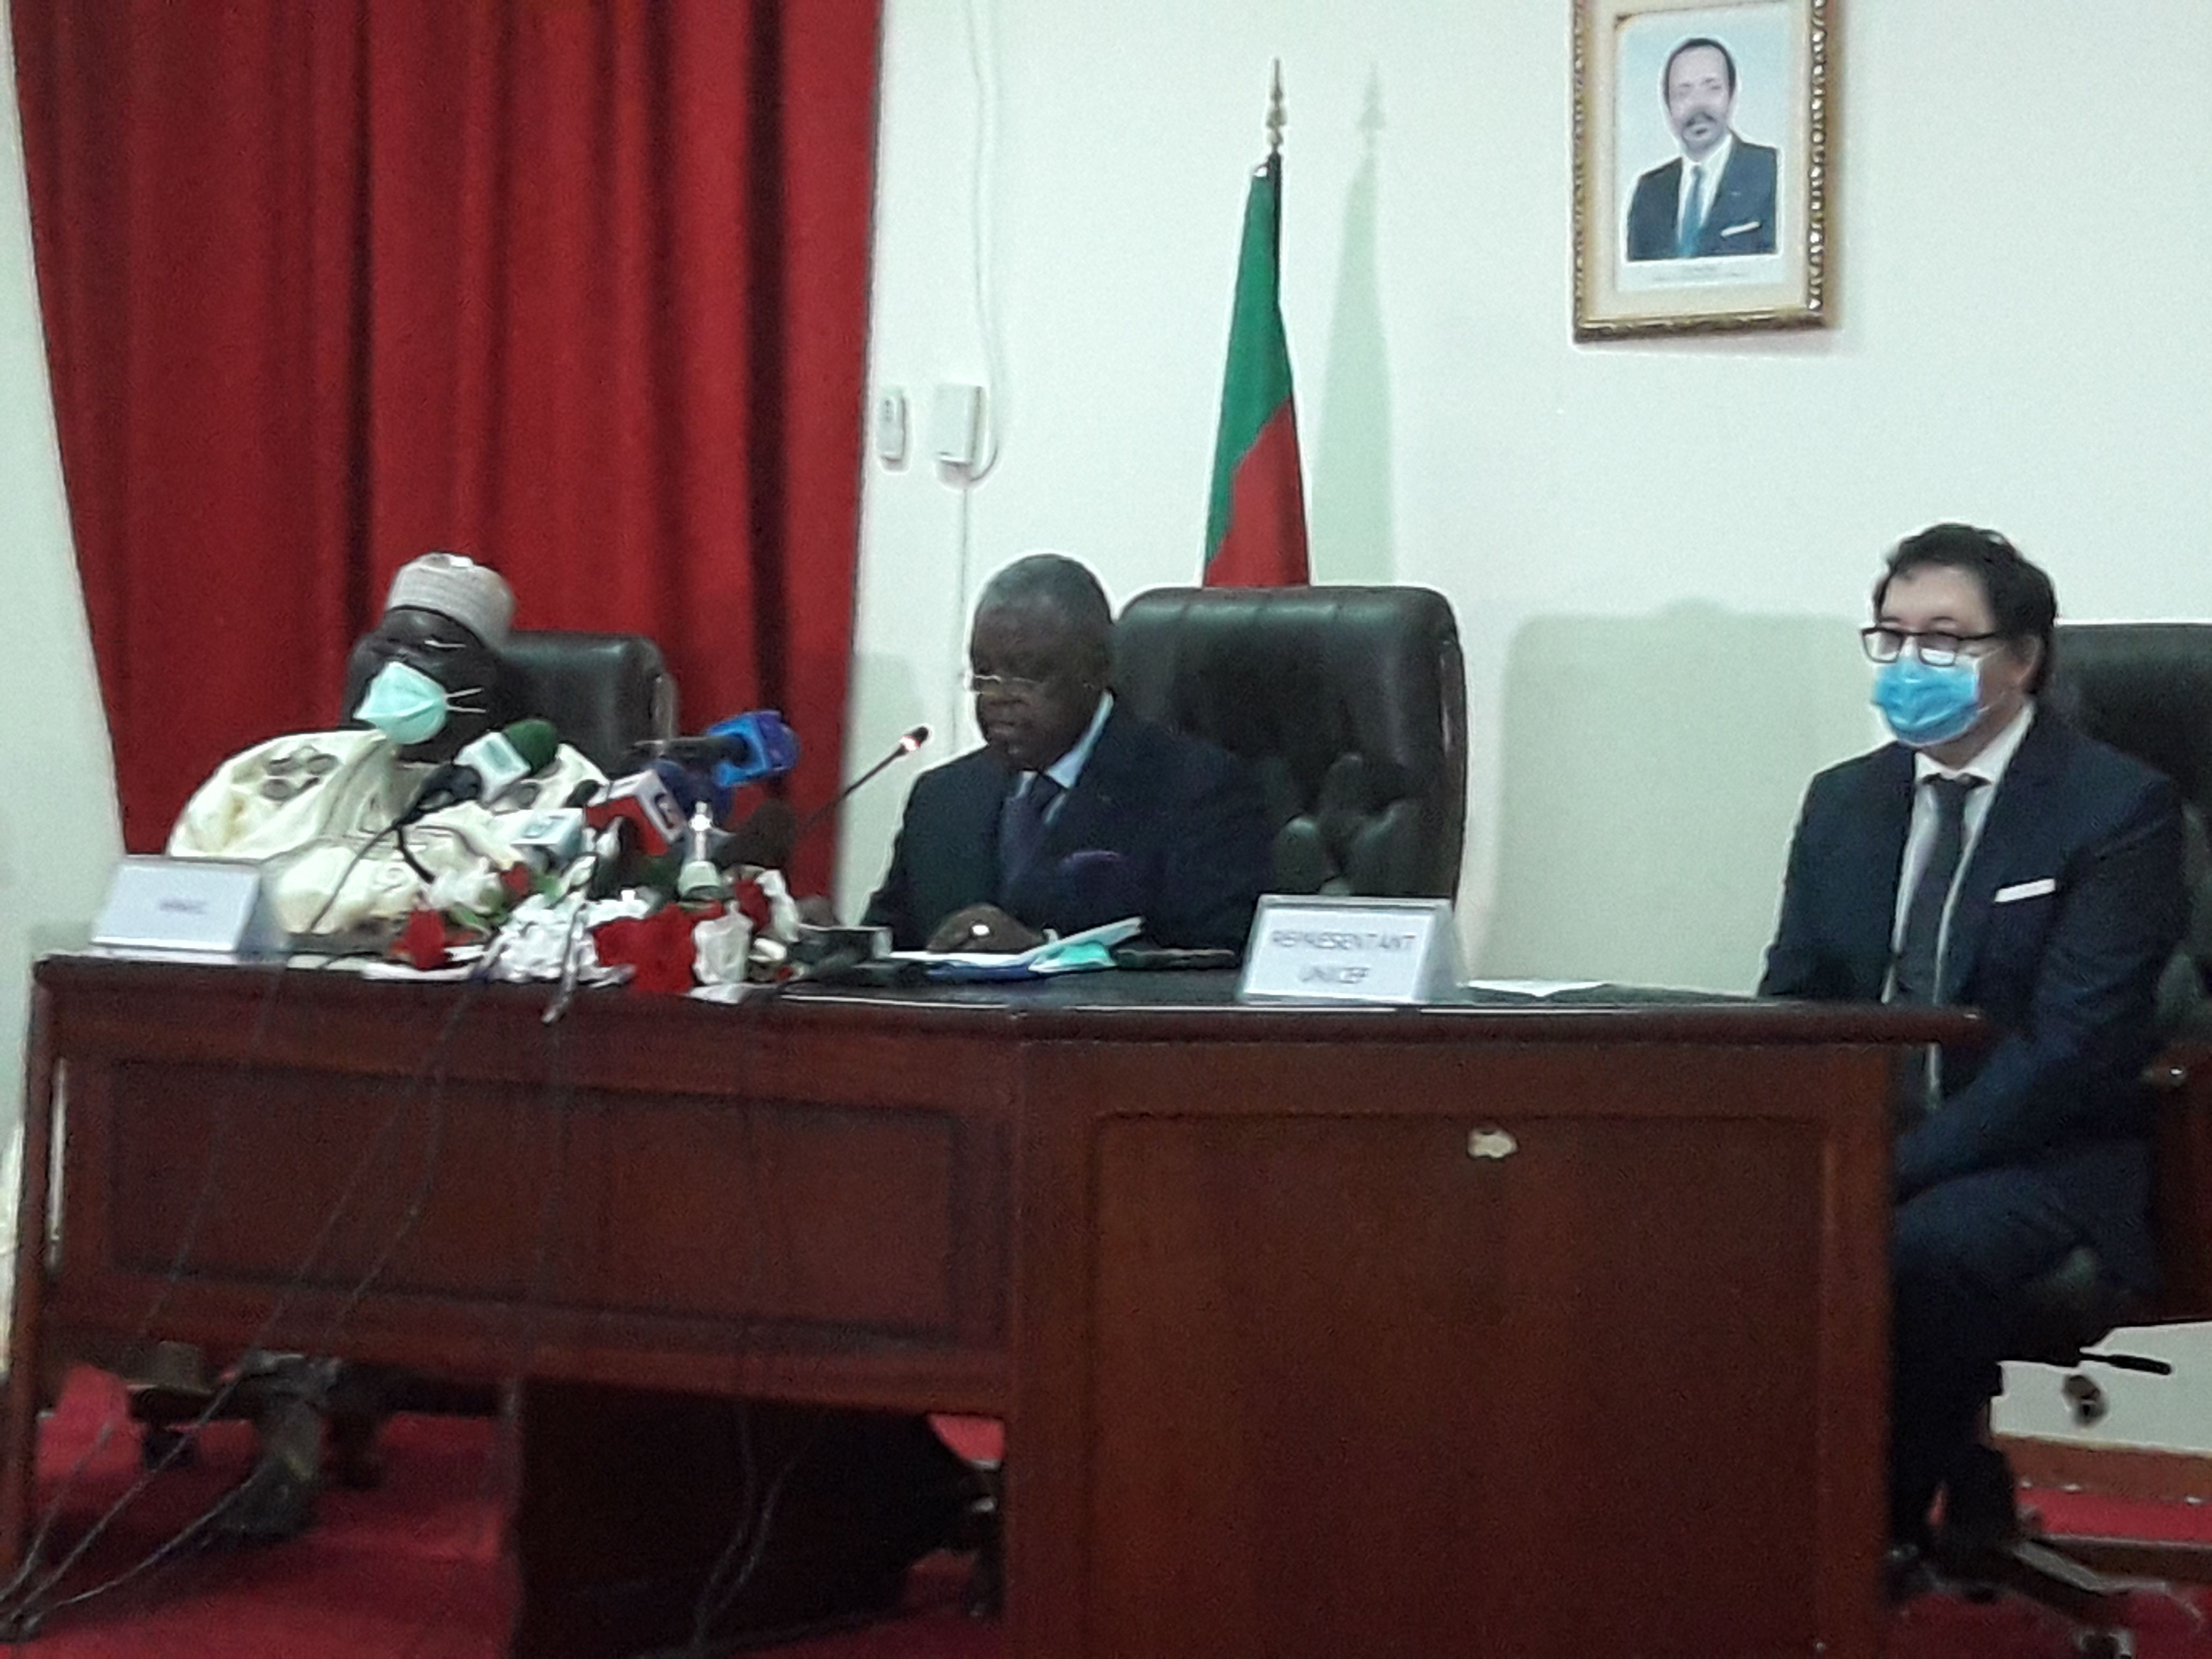

*Sensitization campaigns takes another phase*

The gadgets to be used by the caravans comprised of megaphones, yellow traffic vests and caps, were symbolically handed by the trio to the respective representatives of the mayors, who expressed satisfaction. For twelve days, they are expected comb their respective areas of jurisdiction with proximity campaign messages to combat covid-19.